**Free time (Volný čas)**

**Popiš obrázky**

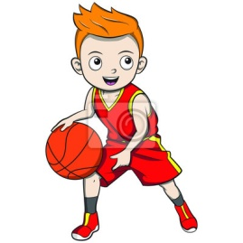 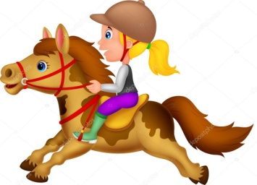 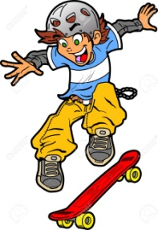

_________________________ ___________________________ __________________________

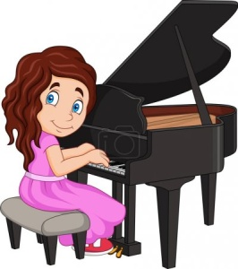 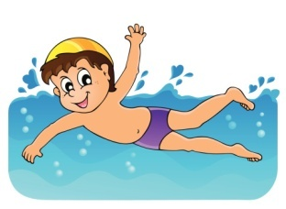 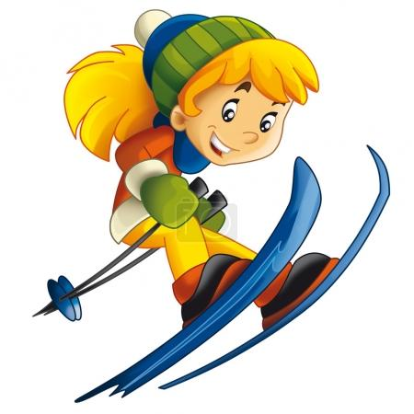

_________________________ __________________________ _________________________

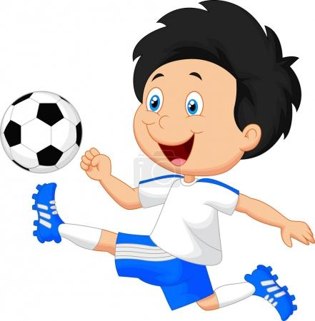 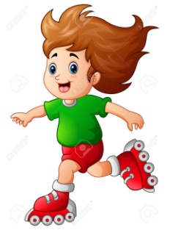

_____________________________ ___________________________

**Doplň písmena a přelož slovíčka (slovní spojení)**

P ___ ___ Y THE ___ I ___ ___O _______________________

___ K ___ _______________________

___K A ___ ___ B ___ A ___ ___ _______________________

S ___ I ___ _______________________

R ___ D ____ A ___O ____ ____ E _______________________

___ L ___ Y F___ O ___ B ___ L ___ ______________________

R ___ ___ L E ___ B ___ A ___ ___ ______________________

P ___ ___ Y ___ A ___ K ___ ___ B ___ L L _____________________

**Hledej anglické výrazy v osmisměrce, vypiš je. Nápovědu najdeš pod osmisměrkou**

|  |  |  |  |  |  |  |  |  |  |  |  |  |
| --- | --- | --- | --- | --- | --- | --- | --- | --- | --- | --- | --- | --- |
| **P** | **J** | **F** | **H** | **K** | **O** | **P** | **Y** | **A** | **Q** | **F** | **E** | **T** |
| **C** | **L** | **G** | **F** | **W** | **U** | **I** | **D** | **O** | **L** | **P** | **F** | **V** |
| **Y** | **A** | **A** | **W** | **E** | **S** | **D** | **R** | **C** | **V** | **F** | **O** | **R** |
| **T** | **F** | **V** | **Y** | **B** | **G** | **T** | **A** | **Z** | **H** | **N** | **O** | **M** |
| **J** | **U** | **I** | **O** | **P** | **L** | **K** | **O** | **G** | **A** | **D** | **T** | **Q** |
| **C** | **B** | **A** | **S** | **K** | **E** | **T** | **B** | **A** | **L** | **L** | **B** | **V** |
| **Y** | **F** | **P** | **I** | **A** | **N** | **O** | **E** | **B** | **F** | **S** | **A** | **Z** |
| **A** | **Q** | **D** | **H** | **J** | **K** | **T** | **T** | **F** | **D** | **S** | **L** | **Y** |
| **F** | **R** | **H** | **O** | **R** | **S** | **E** | **A** | **U** | **H** | **F** | **L** | **D** |
| **S** | **D** | **V** | **M** | **G** | **H** | **N** | **K** | **W** | **I** | **T** | **A** | **J** |
| **X** | **A** | **I** | **D** | **F** | **B** | **H** | **S** | **J** | **U** | **K** | **U** | **V** |
| **D** | **W** | **D** | **G** | **R** | **W** | **Q** | **A** | **E** | **B** | **L** | **S** | **C** |
| **S** | **A** | **R** | **O** | **L** | **L** | **E** | **R** | **B** | **L** | **A** | **D** | **E** |

(hrát, kůň, klavír, plavat, basketbal, jezdit na skateboardu, fotbal, lyžovat, jezdit na koleč. bruslích)